**MHSPLA**

**Junior Varsity State Championships**

**Hosted at: Powers Catholic High School**

**DATE**: **Saturday, March 1, 2025**

**PLACE:** **Powers Catholic High School, 1505 W. Court Street, Flint, Michigan 48503**

**PRE-REGISTRATION DEADLINE:**

**Pre-Registration STARTS at 4:00PM and ENDS** **at 7:00PM** **Tuesday, February 25, 2025**

**NO REGISTRATIONS WILL BE ACCEPTED EARLIER OR LATER**

**ENTRY FEE:** $25.00 CASH or MONEY ORDER (NO personal checks will be accepted)

Lifters MUST PAY entry fee at the weigh-in site.

**NO LATE REGISTRATION OR WALK-INS ALLOWED – ONLY LIFTERS WHO HAVE QUALIFIED FOR THE MHSPLA VARSITY STATE CHAMPIONSHIP MAY PARTICIPATE**

**MEET DIRECTOR: Jeremy Ferman – 810.656.5915 -** [**powerscatholicpowerlifting@gmail.com**](mailto:powerscatholicpowerlifting@gmail.com)

**AWARDS:** Women’s and Men’s Individual Medals First through Fifth Place. Team Awards: Women’s Junior Varsity and Men’s Junior Varsity First through Third Place. Women’s Junior Varsity Division (7th thru 10th grade) and Men’s Junior Varsity Division (7th thru 10th grade)

**ROSTERS**: Coaches submit their roster of qualified lifters with the weight class qualified (if a lifter has qualified in multiple weight classes, please indicate their weight class expected for the lifter to lift in) plus their openers. This roster will be sent to the meet director in a spreadsheet with the Lifter Name, School, Division, Weight Class and Openers by the deadline stated on the registration form **USING THE TEAM ROSTER SPREADSHEET PROVIDED ON OUR MEET PAGE ON HE MHSPLA WEBSITE. NO OTHER FORMATS WILL BE ACCEPTED!!!**

**Please Note: Also on the team roster spreadsheet list the coaches that will be on the floor with the lifters. Only 2 coaches allowed if under 10 lifters on the roster and an additional coach can be added for each additional 10 lifters. If the coach is not listed on the spreadsheet he or she will not be allowed on the floor during competition.**

Email the spreadsheet listing all participating members to:

[**powerscatholicpowerlifting@gmail.com**](mailto:powerscatholicpowerlifting@gmail.com)

**When the lifter checks-in at the meet, the lifter must present student ID w/picture– NO Exceptions!!!! After the lifter registers at the meet, he/she will be weigh-in, wearing a short sleeve-shirt, shorts and socks. No shoes, jackets, sweatshirts, hats, earbuds, headphones etc. will be allowed. This weight will be documented and used for the competition. There will be check scales available and ONE attempt on the official scale only. Your exact weight will determine your weight class. You must weigh in the range of the weight class you qualified in. For example, if lifter qualified in the 165 LB weight class – the lifter must weigh between 155.1 and 165.0 pounds. If the lifter is too light or too heavy, the lifter will not be able to complete in the meet. NO EXCEPTIONS!!!**

**ALL LIFTERS MUST BE REGISTERED AND WEIGHED IN 60 MINUTES PRIOR TO THE SCHEDULED START OF LIFTING. PLEASE PLAN ACCORDINGLY.**

**COACHES: To ease check in please try and check in as a team. Please remind your lifters at the official weigh-ins they still need to show their school ID w/picture and have their lifter band on. (Women at their registration time and men at their registration time.) IF A LIFTER SCRATCHES AFTER THE ROSTER SPREADSHEET HAS BEEN TURNED IN TUESDAY, THE MONEY IS STILL OWED IN FULL. If you turned in 10 women on the roster and only 8 lift, you still 250 dollars for 10 lifters.**

**Doors open at 6:45am**

**WOMEN DIVISIONS MEN DIVISIONS**

**CHECK-IN BEGINS**: 7:00am **CHECK-IN BEGINS**: 11:30am

**CHECK-IN ENDS:** 8:00am **CHECK-IN ENDS:** 12:30pm

**COACHES MEETING**: 8:00am **COACHES MEETING**: 12:30pm

**LIFTER MEETING**: 8:30am **LIFTER MEETING**: 1:00pm

**WARM-UP**: 8:40am **WARM-UP**: 1:15pm

**LIFTING BEGINS**: 9:00am **LIFTING BEGINS**: 1:30pm

**ELIGIBILITY:** Open to all 7th-10th grade lifters who have qualified at a 2024-2025 season MHSPLA Regional Meet. Students MUST be enrolled in the school that they are lifting. All students MUST be eligible to compete according to their school’s eligibility standards. ALL LIFTERS MUST BE DRUG FREE FOR A MINIMUM OF 36 MONTHS.

**RULES**: MHSPLA rule will govern this meet.

**WEIGHT CLASSES:**

MEN: 114, 123, 132, 145, 155, 165, 181, 194, 207, 220, 242, 275, SHW

WOMEN: 105, 114, 123, 132, 140, 148, 155, 165, 181, 198, 220, 242, SHW

**EQUIPMENT:**

This will be a RAW Meet.

Shorts and Short Sleeve T-shirt.

No singlets or squat shorts allowed.

No tights

Max 4-inch belt ONLY. No padding in back or any type of Velcro straps allowed.

Compression shirts/shorts are acceptable.

Long socks to the knee REQUIRED for dead lift.

You must wear shoes when lifting. No sandals, slides, crocs or bare feet allowed when lifting in competition.

No hats, caps, earbuds, headphones when lifting in competition

**ADMISSIONS**: $ 5.00 individual (11-59 years of age)

Free for 10 years old and under, military, police, Fire/EMS (ID required) and 60+ years old.

POWERS CATHOLIC HIGH SCHOOL | OUTSIDE

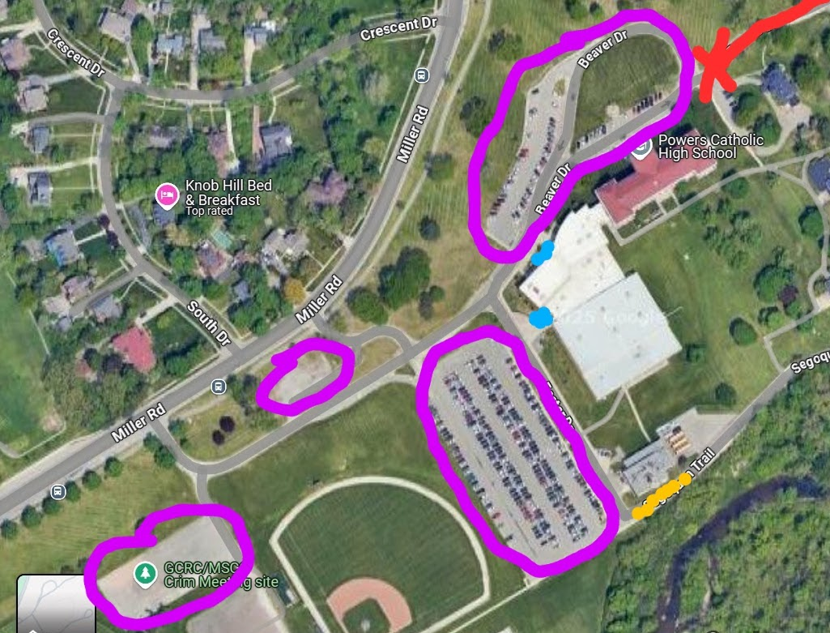

PLEASE ENTER THE WEST DRIVE

BLUE = ENTRANCE

RED = DO NOT ENTER OR PARK

PURPLE = PARKING

YELLOW = BUS PARKING

POWERS CATHOLIC HIGH SCHOOL | INSIDE

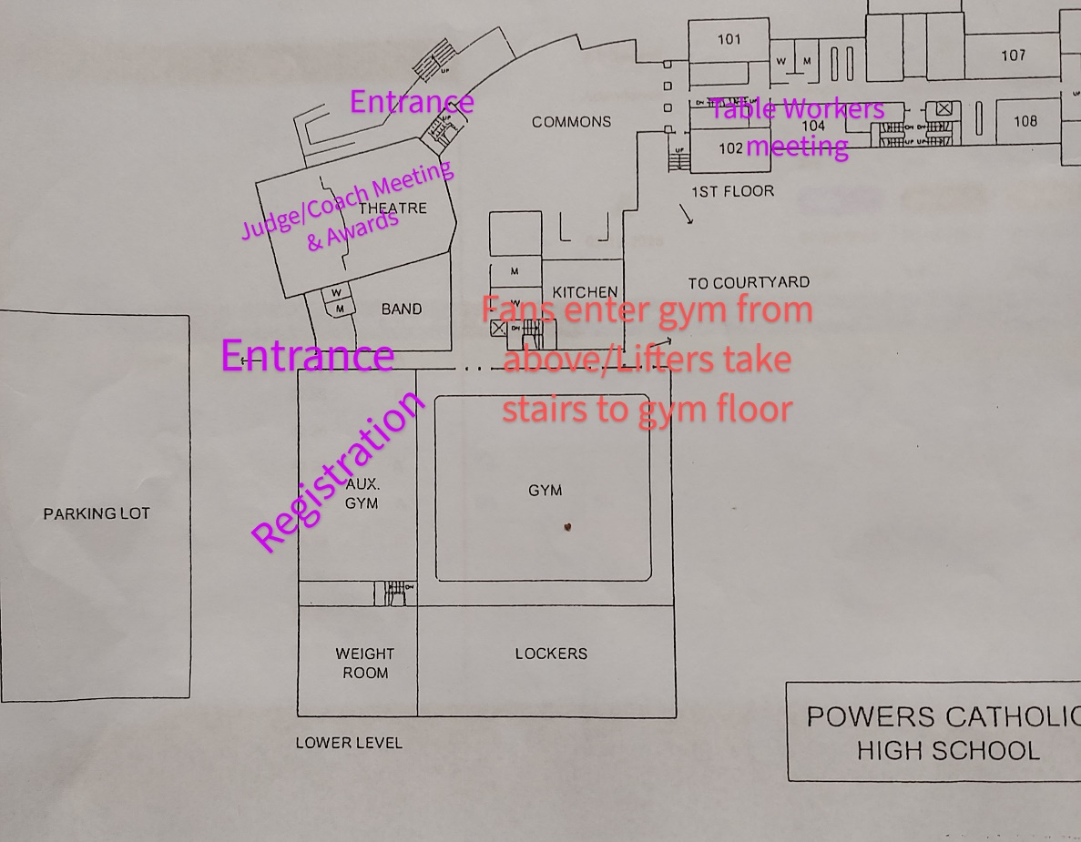

**2024-2025 MHSPLA Junior Varsity State Championships**

Entry Form

$25.00 per lifter registration

Name __________________________________ School System: __________________________________

Grade: _______________ Weight Class: ________________ Gender: _________________

Home Address: ___________________________City:_______________State:______Zip:______________

Phone Number: (______)______________________

Division: _______ Junior Varsity Women _______ Junior Varsity Men

Openers: _______ Squat _______ Bench _______ Deadlift

In consideration of the acceptance of my entry form in this Powerlifting competition, I intend to be legally responsible for not only myself, but also my heirs, my executors, and my administrators. In signing this release from liability, I waive and release everyone connected with competition from any and all liability, which may arise from this competition.

In addition to the foregoing, I specifically release Powers Catholic HS, Powers Catholic Powerlifting, Lansing Diocese, the meet directors, meet assistants and anyone connected with this contest, regardless of his/her contribution.

|  |  |
| --- | --- |
| Participant’s Signature |  |
| Parent Signature |  |
| Parent Name Printed |  |

Payment must be **CASH**, **SCHOOL ISSUED CHECK**, or **MONEY ORDER** ONLY – Due at registration (No personal checks will be accepted.)

Please make school issued check or money orders out to ***Powers Catholic HS - Powerlifting*** ONLY.

**RELEASE FROM LIABILITY AND CONSENT TO DRUG TEST**

In consideration of the acceptance of my entry in the Power lifting competition I intend to be legally bound, for not only myself but also for my heirs, my executors, and my administrators. By signing this release from liability I waive and release everyone connected with competition from any and all liability, including any results of negligence which may arise from this competition. Moreover I agree that any testing method which the meet director and the sponsors of this meet use to detect the presence of strength-inducing drugs SHALL BE CONCLUSIVE. That is, whether I think the results of the tests are right or wrong, I agree that I have no right to challenge the results of the drug tests. I further agree to submit to any physical tests which may be necessary to complete drug testing. Should I fail to pass the drug test I agree to forfeit any trophy or award which I otherwise have won. I understand and agree that if I fail to pass the drug tests, my name will appear on a published list of suspended members. If determined that I have failed the drug test, I agree to waive any claim for which legal relief is available. I agree to pay any attorney fee and litigation expenses incurred by any person, real or corporate, whom I may sue in an effort to challenge this Release form. I understand that my agreement to pay attorney fees and litigation expenses is the Sine Qua Non for the acceptance of my entry in this contest. If any provision of this release from liability shall be deemed by a court of competent jurisdiction to be invalid, the remainder of this Release from Liability shall remain in full force and effect. I also certify with my signature that this release/agreement cannot be modified orally.

SIGNATURE IN FULL OF APPLICANT__________________________________________________DATE:___________

SIGNATURE IN FULL OF PARENT OR GUARDIAN_________________________________________________________________________DATE:___________

**COACHES RELEASE FROM LIABILITY**

This form is for all coaches that are listed when the rosters are sent in to the host schools they may enter the designated lifting area. All coaches that are listed must sign this release from liability. All lifters need only to sign the entry form. This form **does not** provide free entry to any and all events

NAME: __________________________________________________________

ADDRESS: _______________________________________________________

CITY: _______________________________ STATE______ ZIP_________

PHONE: _____________________________________________

In consideration of my presence at or participation in, I intending to be legally bound, hereby, for myself, my executors, and administrators, waive and release Powers Catholic HS, Powers Catholic Powerlifting, Lansing Diocese, the Meet Director, their agents, representatives, committees, and members from any and all claims or Rights to damage from injuries or losses suffered by me directly or indirectly participating in or attending the current MHSPLA Regional Meet.

SIGNATURE IN FULL OF

APPLICANT_________________________________________________DATE:___________________

In consideration of the acceptance of my presence at or participation in this Powerlifting competition I intend to be legally bound, for not only myself but also for my heirs, my executors, and my administrators. I signing this release from liability I waive and release everyone connected with competition from any and all liability including any results of negligence, which may arise from this competition.

SIGNATURE IN FULL OF

APPLICANT_________________________________________________DATE:_____________________.